**REPORT**

Zajęcia: Analog and digital electronic circuits

Teacher: prof. dr hab. Vasyl Martsenyuk

**Lab 1**

Date: 19.10.2024

**Topic:** Task Windowing

**Variant7**

Mateusz Łysoń

Informatyka II stopień,

niestacjonarne,

1 semestr,

Gr.1b

1. **Problem statement:**

The task is to generate three sine signals with given frequencies for a specific sampling frequency and amplitude, within a specified number of samples. The objective is to analyze the signals using Discrete Fourier Transform (DFT) and Discrete-Time Fourier Transform (DTFT) with different window functions (rectangular, Hann and flat-top). The DFT spectra will be normalized, and the DTFT spectra will be normalized to their main lobe maximum. The goal is to assess the performance of different windows and understand the difference between the signals at .

**2. Input data:**

Input as stated in 7. variant:

* F1 = 400 Hz
* F2 = 400.25 Hz
* F3 = 399.75 Hz
* Fs = 600 Hz
* N = 3000
* A = 3

1. **Commands used (or GUI):**

import numpy as np

import matplotlib.pyplot as plt

from scipy.signal.windows import hann, flattop

from numpy.fft import fft, fftshift

# Parameters

f1 = 400 # Frequency 1 in Hz

f2 = 400.25 # Frequency 2 in Hz

f3 = 399.75 # Frequency 3 in Hz

fs = 600 # Sampling frequency in Hz

N = 3000 # Number of samples

A = 3 # Amplitude

# Time vector

k = np.arange(N)

# Generate sine signals

x1 = A * np.sin(2 * np.pi * f1 * k / fs)

x2 = A * np.sin(2 * np.pi * f2 * k / fs)

x3 = A * np.sin(2 * np.pi * f3 * k / fs)

# Generate window functions

wrect = np.ones(N) # Rectangular window

whann = hann(N, sym=False) # Hann window

wflattop = flattop(N, sym=False) # Flat-top window

# Apply windows to signals

X1wrect = fft(x1 * wrect)

X2wrect = fft(x2 * wrect)

X3wrect = fft(x3 * wrect)

X1whann = fft(x1 * whann)

X2whann = fft(x2 * whann)

X3whann = fft(x3 * whann)

X1wflattop = fft(x1 * wflattop)

X2wflattop = fft(x2 * wflattop)

X3wflattop = fft(x3 * wflattop)

# Define DFT normalization function

def fft2db(X):

N = X.size

Xtmp = 2 / N * X # Normalize for sine amplitudes

Xtmp[0] /= 2 # bin for f=0 Hz exists only once

if N % 2 == 0:

Xtmp[N//2] /= 2 # fs/2 bin exists only once for even N

return 20 * np.log10(np.abs(Xtmp))

# Frequency vector for DFT

df = fs / N

f = np.arange(N) * df

# Plot normalized DFT spectra (175 Hz to 225 Hz)

plt.figure(figsize=(12, 8))

plt.subplot(3, 1, 1)

plt.plot(f, fft2db(X1wrect), label='f1 Rectangular')

plt.plot(f, fft2db(X2wrect), label='f2 Rectangular')

plt.plot(f, fft2db(X3wrect), label='f3 Rectangular')

plt.xlim(175, 225)

plt.ylim(-60, 0)

plt.grid(True)

plt.legend()

plt.subplot(3, 1, 2)

plt.plot(f, fft2db(X1whann), label='f1 Hann')

plt.plot(f, fft2db(X2whann), label='f2 Hann')

plt.plot(f, fft2db(X3whann), label='f3 Hann')

plt.xlim(175, 225)

plt.ylim(-60, 0)

plt.grid(True)

plt.legend()

plt.subplot(3, 1, 3)

plt.plot(f, fft2db(X1wflattop), label='f1 Flat-Top')

plt.plot(f, fft2db(X2wflattop), label='f2 Flat-Top')

plt.plot(f, fft2db(X3wflattop), label='f3 Flat-Top')

plt.xlim(175, 225)

plt.ylim(-60, 0)

plt.grid(True)

plt.legend()

plt.show()

# DTFT-like spectra using zero-padding

def winDTFTdB(w):

N = w.size

Nz = 100 * N # Zero-padding length

W = np.zeros(Nz)

W[0:N] = w

W = np.abs(fftshift(fft(W))) # FFT and shift

W /= np.max(W) # Normalize to mainlobe maximum

W = 20 * np.log10(W) # Convert to dB

Omega = 2 * np.pi / Nz * np.arange(Nz) - np.pi # Digital frequencies

return Omega, W

# Plot window DTFT spectra normalized to mainlobe maximum

Omega, Wrect = winDTFTdB(wrect)

Omega, Whann = winDTFTdB(whann)

Omega, Wflattop = winDTFTdB(wflattop)

plt.figure(figsize=(12, 8))

plt.plot(Omega, Wrect, label='Rectangular')

plt.plot(Omega, Whann, label='Hann')

plt.plot(Omega, Wflattop, label='Flat-Top')

plt.xlim(-np.pi, np.pi)

plt.ylim(-120, 10)

plt.grid(True)

plt.legend()

plt.show()

Link to remote repostorium: https://github.com/sensorbtf/Digital-signal-processing

1. **Outcomes:**

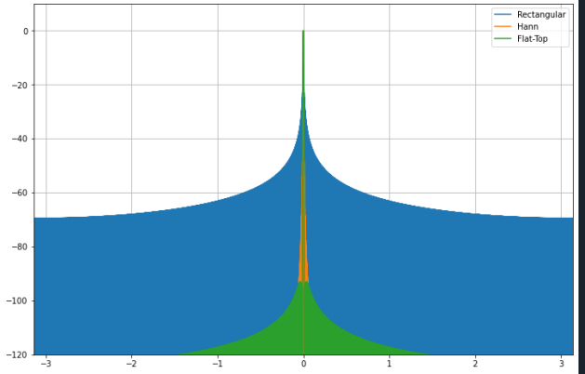

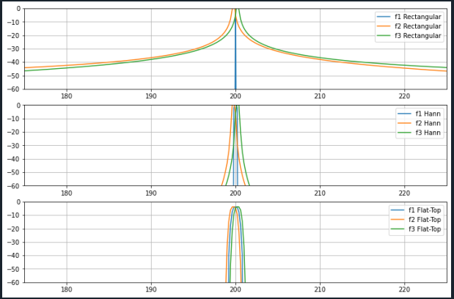

1. **Interpretation of the Results:**

**DFT Spectra**:

* 1. The **rectangular window** shows more side lobes and spectral leakage, making it the worst choice in terms of frequency resolution.
  2. The **Hann window** shows fewer side lobes and better attenuation but still allows some leakage.
  3. The **flat-top window** has the best suppression of side lobes, resulting in cleaner spectra but with a wider main lobe.

**DTFT Spectra**:

* 1. The **flat-top window** has the best main lobe suppression, but at the cost of a wider lobe.
  2. The **Hann window** performs better than the rectangular window in both side lobe suppression and main lobe width.

****Why do the results for** F1 **and F2 differ?****

* 1. The signals at f1 = 300 Hz and f2 = 300.25 Hz differ because their frequency spacing is very small (0.25 Hz). This small frequency difference is better resolved by windows that reduce spectral leakage, such as the **Hann** and **flat-top** windows, compared to the **rectangular** window, which spreads the energy across a broader range of frequencies due to leakage.